**Question 1.**

**a.** First, I analyzed the data trend by plotting sales over the given periods. The detailed calculations are available in the sheets named “Question1.a-sheet1” and “Question1.a-sheet2”

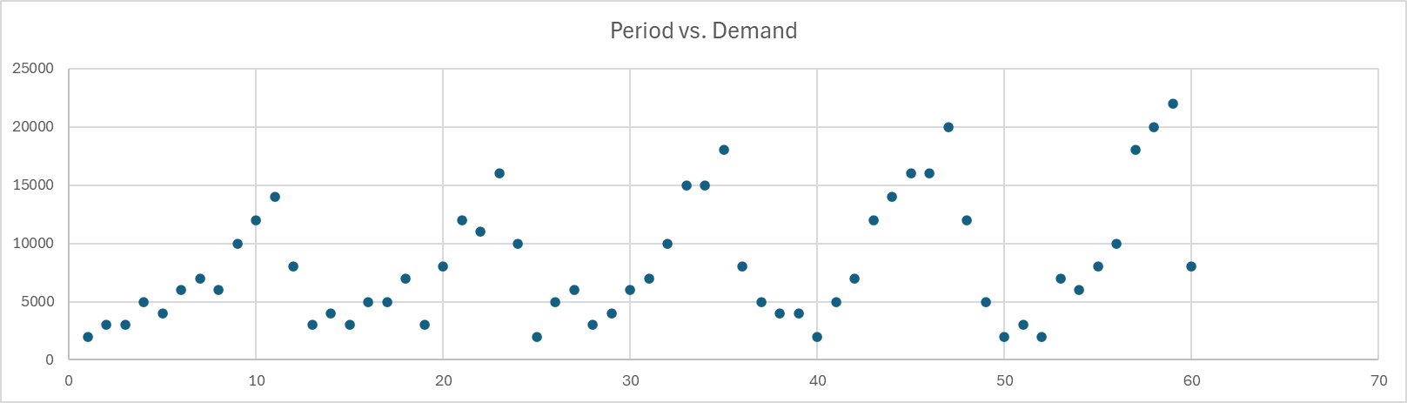

From this visualization, we can observe that the sales exhibit both yearly seasonality and an overall trend.

Next, the deseasonalized demand and seasonal factors were calculated by the following relations.

$${\overline{D}}_{t}=\frac{1}{24}\left(\sum_{i=t-6}^{t+5}{D_{i}}+\sum_{i=t-5}^{t+6}{D_{i}}\right)$$

$${\overline{S}}_{t}=\frac{D_{t}}{{\overline{D}}_{t}}$$

The table below summarizes the results.



Next, to estimate future demand, I formulated the static model as follows.

$$F_{t}=\left(L+tT\right)S_{t}$$

To determine each parameter, I first performed linear regression on the deseasonalized demand.



Additionally, I calculated the seasonal factor for each month by averaging the corresponding seasonal factors derived from the data.

The resultant parameters were obtained as follows.



Here, $S_{12i+j}=S_{j}$, for $i=1,2,3,4,5$ and $j=1,2,…,12$

Finally, the Year 6 forecast is as follows.



With this model, TS, MAD, MAPE, MSE are calculated as follows.



**b.** To analyze the overall trend, I plotted the demand against the period.

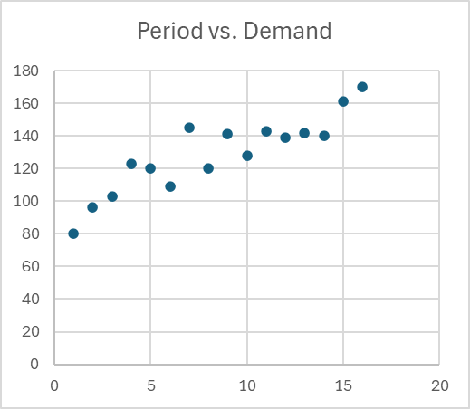

The demand shows a clear trend that cannot be adequately captured by just a single parameter (i.e., level). Therefore, I initially hypothesized that Holt’s model would provide a better fit.

Exponential smoothing, detailed calculations are in “Question1.b-sheet1”





Holt’s method, detailed calculations are in “Question1.b-sheet2” and “Question1.b-sheet3.” Note that linear regression was performed to obtain $L_{0}$ and $T_{0}$, with its result in “Question1.b-sheet3.”





All the metrics of Holt’s model are smaller than exponential smoothing’s, implying that the Holt’s model fits better than the other. Therefore, the initial guess I had seems correct.

**Question 2.**

a.

b.